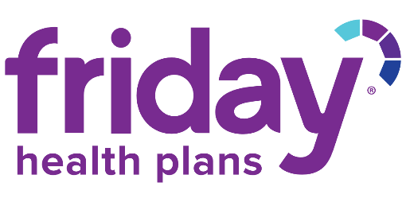

2021 Special Enrollment Period
The 2021 Open Enrollment period has ended and enrollment in a Friday Health Plan can only occur if a Qualifying Life Event (QLE) has been experienced. A list of Qualifying Life Events and Required Documentation is below.
Qualifying Life Event | Required Documentation
Involuntary loss of coverage | Proof of prior coverage including Certificate of Creditable Coverage
Loss of Medicaid or CHP+ coverage | Letter from Medicaid verifying loss of coverage and coverage dates
Loss of coverage due to change in dependent status such as divorce or legal separation, death, or turning 26 | Divorce decree or legal separation  Death certificate or obituary  Proof of age and evidence of loss of creditable coverage
Gaining or becoming a dependent through birth, adoption, placement for adoption, or placement in foster care | Birth certificate, adoption documents, or foster care documents
Marriage or civil union | Marriage license or common law documentation
Relocation to Colorado from a foreign country or United States territory | Utility statement, rental/purchase agreement or another creditable source listing new address
Relocation to a new county within Colorado | Proof of prior coverage in the last 60 days and utility statement, rental/purchase agreement or another creditable source listing new address
Court order for coverage | Court documents stating same
Other (not listed above) | Documents providing verification of QLE

To ensure your application is processed correctly:

- Applications must be received within 60 days after the triggering event. To avoid a gap in coverage, completed applications may be submitted up to 60 days in advance of a known and eligible triggering event.
- Supporting documentation is required before an application can be approved for coverage. Please send copies only, as originals will not be returned.
- Email the required documentation to: sep@fridayhealthplans.com
- Once the application has been approved, the initial premium payment must be paid.
- If additional information is required, you will be contacted directly.
- Coverage will not be in force without payment and the required documentation.
- If you have any questions, please call Friday Health Plans 844-535-2000.

